Thank you for contacting me.
The installation steps are as follow.

1. Open File>Options>Trust Center>Trust Center Settings…
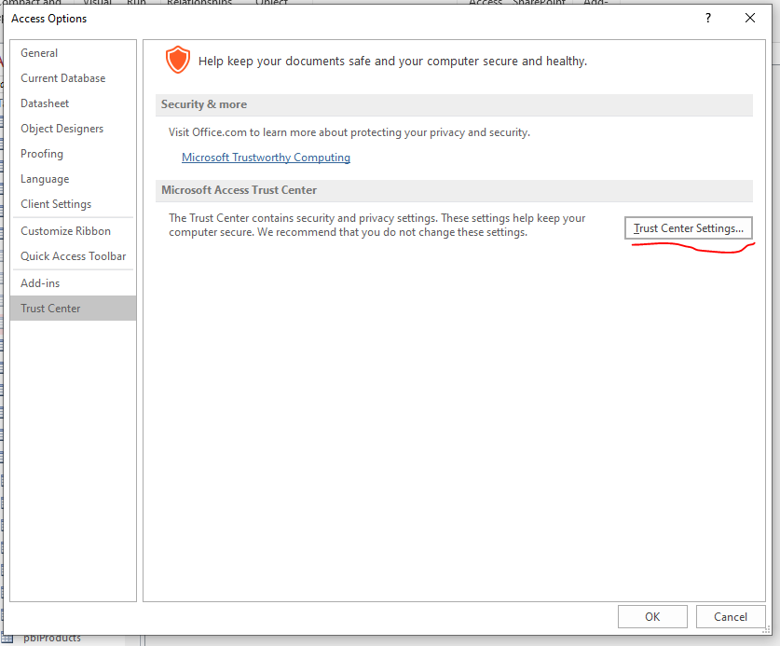
- Allow add-ins
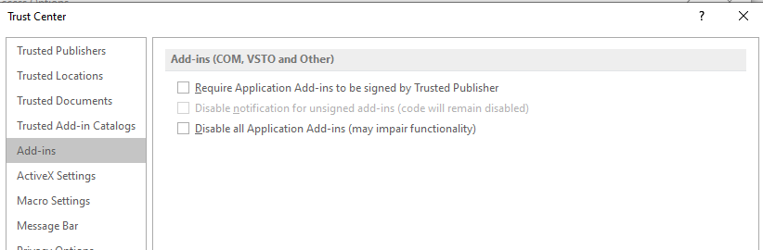
- Allow macros
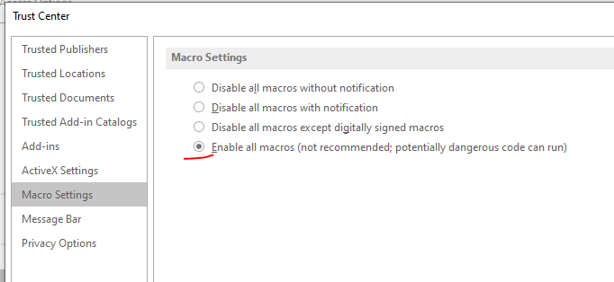

2. Install add-in as Administrator
a- Open MsAccess.exe as Administrator
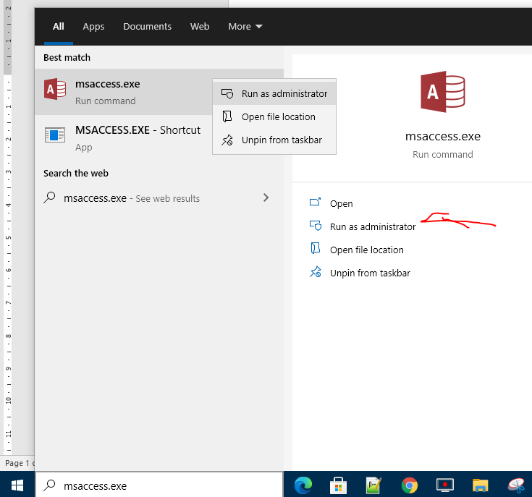
b- Install add-in
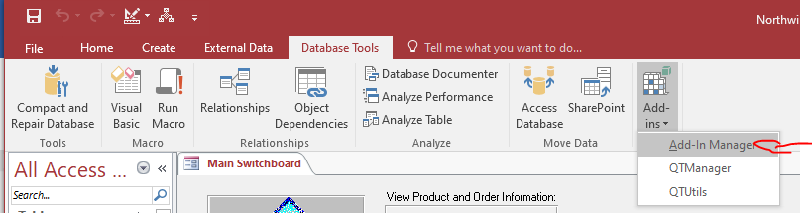

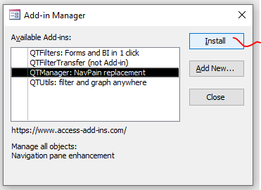

If the installation is successful, you will see an X to the left of the add-in name.
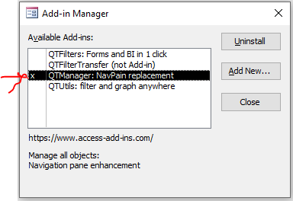

3. Reopen Access and load add-in (now it should be in the list of available add-ins)
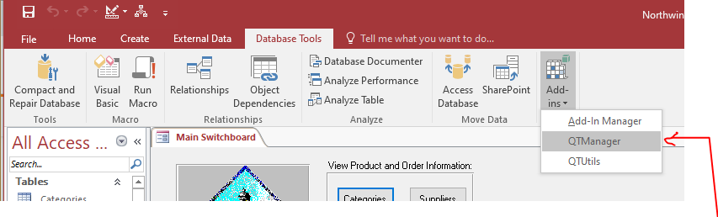
If you get an error the first time you load the add-in, please reopen Access as usual, then load the new add-in before loading any other add-in.
If there is still a problem, please provide me a screenshot and your country name.
Thanks.
Arie.
Icad01@gmail.com

